Pomp
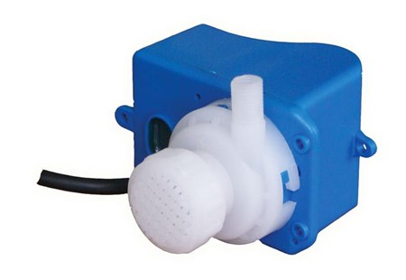

Technical Data
ITEM | RANGE LH | POWER | HZ
020022NMM | 700-750 | V 220/240 | 50 / 60
020076NMM* | 1500-1800 | V 220/240 | 50 / 60
020083NMM* | 700-750 | V 220/240 | 50 / 60
020084NMM | 700-750 | V 110/115 | 50 / 60
020492 | 6000 | V 220/230 | 50 / 60
* 4 mts cable

