TB 150 Special
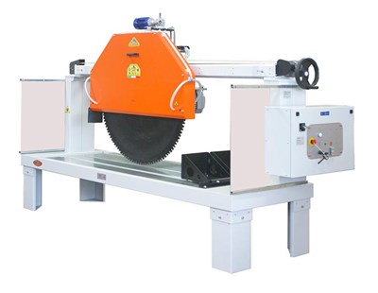

Technical Data
ITEM | MOD. |  |  | 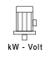 | 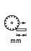 | 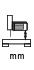 | 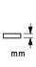 | 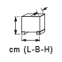
150004 | TB 150 SPECIAL - 1000 | 1000 | 900 | 7,5 - 400 | 1500 | 550 | 400 | 320x105x167 | 506
150006 | TB 150 SPECIAL - 1000 AUTO | 1000 | 900 | 7,5 - 400 | 1500 | 550 | 400 | 320x108x177 | 546
150008 | TB 150 SPECIAL - 1200 | 1200 | 900 | 11 -400 | 1450 | 550 | 400 | 320x108x177 | 516
150010 | TB 150SPECIAL - 1200 AUTO | 1200 | 900 | 11 - 400 | 1450 | 550 | 490 | 320x108x177 | 556

