Bolt 90
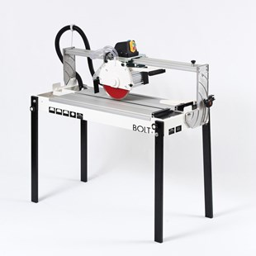
Raimondi Bolt 90 zaagmachine
- 1.1 Kw motor
- 90cm zagen
- 63x63 diagonaal
- 45 graden zagen

